**Seeking 1-3 2D artists to participate in a Roguelike project im working on.**

It would be up to you to literally run wild with the art style and design as long as the general keywords remain...

Meaning I.E. Wizard, Idleing, with a staff, (at the moment the color scheme is even up to you, im not commited to purple)

We will need (for now) basically a wizard guy as the main character... WHATEVER you make here will lend HEAVILY into the main theme of the game going forward so imagine your making it your own story.

We’re currently calling it "The Verdant Paths" but even that is subject to change depending... as long as the name is hinting at pathways and winding trails

The game uses a modified a* pathing algorithm to procedurally generate paths that im trying to draw attention to subtly with the name, and a lot of the project is designed to display the general understanding of procedural systems and algorithms, as well as other complex systems.

All in all this is a good opportunity for a few artists to stretch their wings.  
  
We’ll be needing:

* Sprite sheets for the environment itself (Med - Difficulty / High - Importance / Low - Workload)
* Sprite sheets for the characters ( High - Difficulty / Very High - Importance / High - Workload(unlimited))
* Sprite sheets for the collectibles (Med - Difficulty / Med - Importance / Med - Workload)
* Sprite sheets for the UI / HUD (Med - Difficulty / Very High - Importance / Minimal - Workload)

**Pitches**  
Pitch 1:

You are a wandering wizard trapped on the Verdant Paths — endless, shifting stone trails overrun by mushrooms and crystal growths.

To survive, you must gather food and mine magical gems that power your spells before the paths claim you.

Pitch 2:

A lone wizard walks the Verdant Paths — ancient stone routes that twist endlessly through moss, fungus, and crystal veins.

Food is scarce. Magic is unstable.

To survive, you must scavenge, mine arcane gems, and use their power wisely as the paths grow longer, stranger, and more dangerous.

Pitch 3:

No one remembers who built the Verdant Paths.

Stone corridors stretch forever, choked with moss, glowing fungi, and crystalline growths that hum with unstable magic. Those who enter rarely leave.

You are a wandering wizard, surviving on what little food you can find and siphoning power from raw gems to fuel your spells. Each step forward leads deeper into the unknown — and the paths never end.

**Environment**  
  
Grass Sprite Sheet (This is the Current asset but NOT what I’m asking for this is currently just a place holder / example).  
What I REALLY want is :   
Sprite sheets that are

* Tileable
* Seamless
* Sliceable in unity OR presliced in a sheet or individual sprites

the grass and stones and path aren't exactly seamless so it looks a little funky  
I would want these to adhere to the bullets above. (The exit is also wrong *It needs to be the same size as all the rest of the tiles)  
I’d like the environment to be like kinda swampy / grassy / mossy with some scattered stone about) and some of the tiles also need to be ores (the ores are subject to change) right now their seamless tiles, but I am thinking I will change them to spawn ontop of the tiles

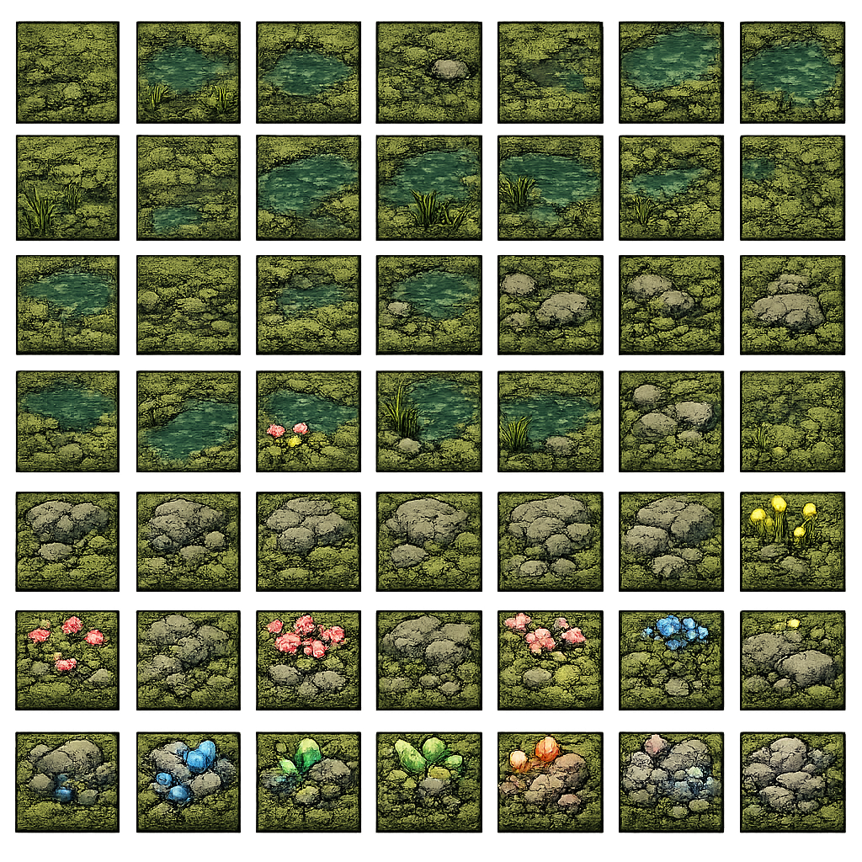

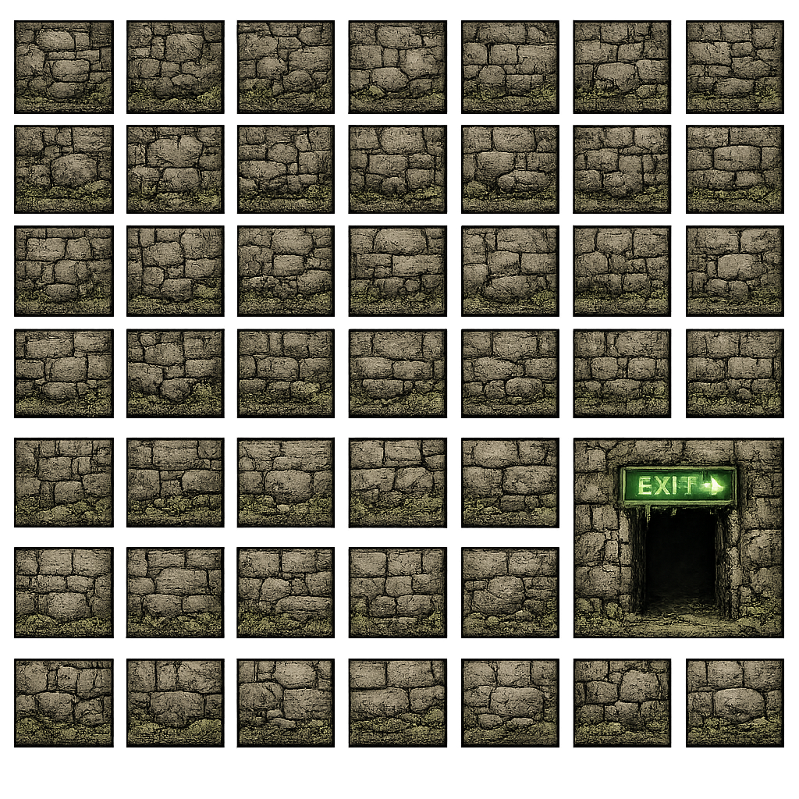

**Character Sheets**

For now I need 1 Player Character, and 2 enemies (if we’re adventurous, an elite and a boss too!)

Sheets would NEED to be Sprite anime with:

* Idle
* Walk
* Attack
* Hurt

I’d like to EVENTUALLY get Left, Up, and Right but for now JUST left will work fine. ALSO this will be an on going project, so we’ll eventually need multiple types of attacks for the player (Spell cast, ranged, melee, etc.) and as the game progresses more enemies and bosses. This is a great opportunity for anyone wanting to really stretch their 2D Anim wings!

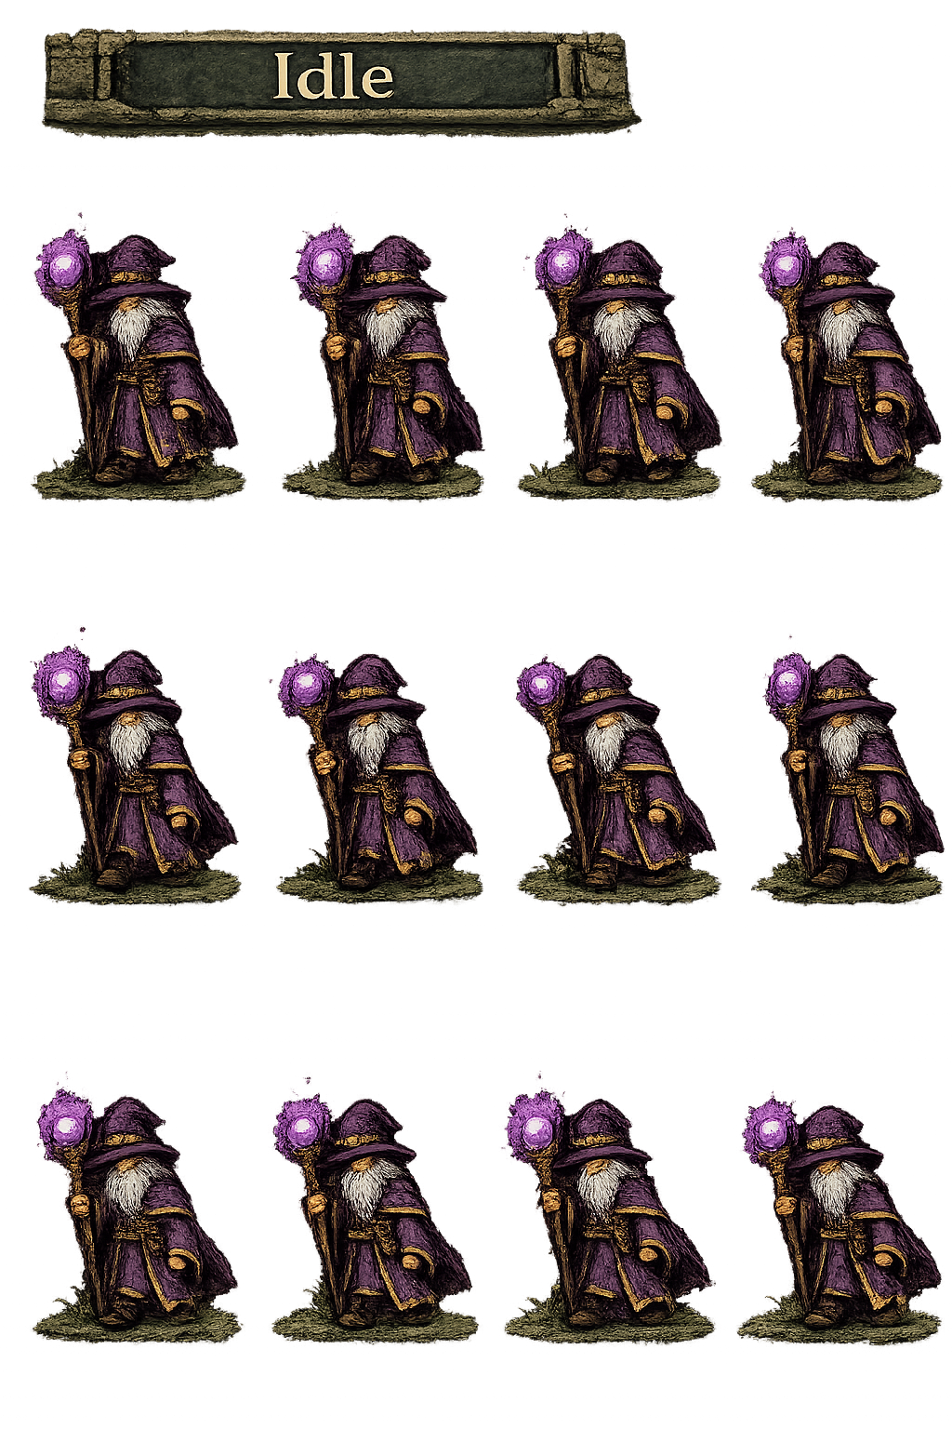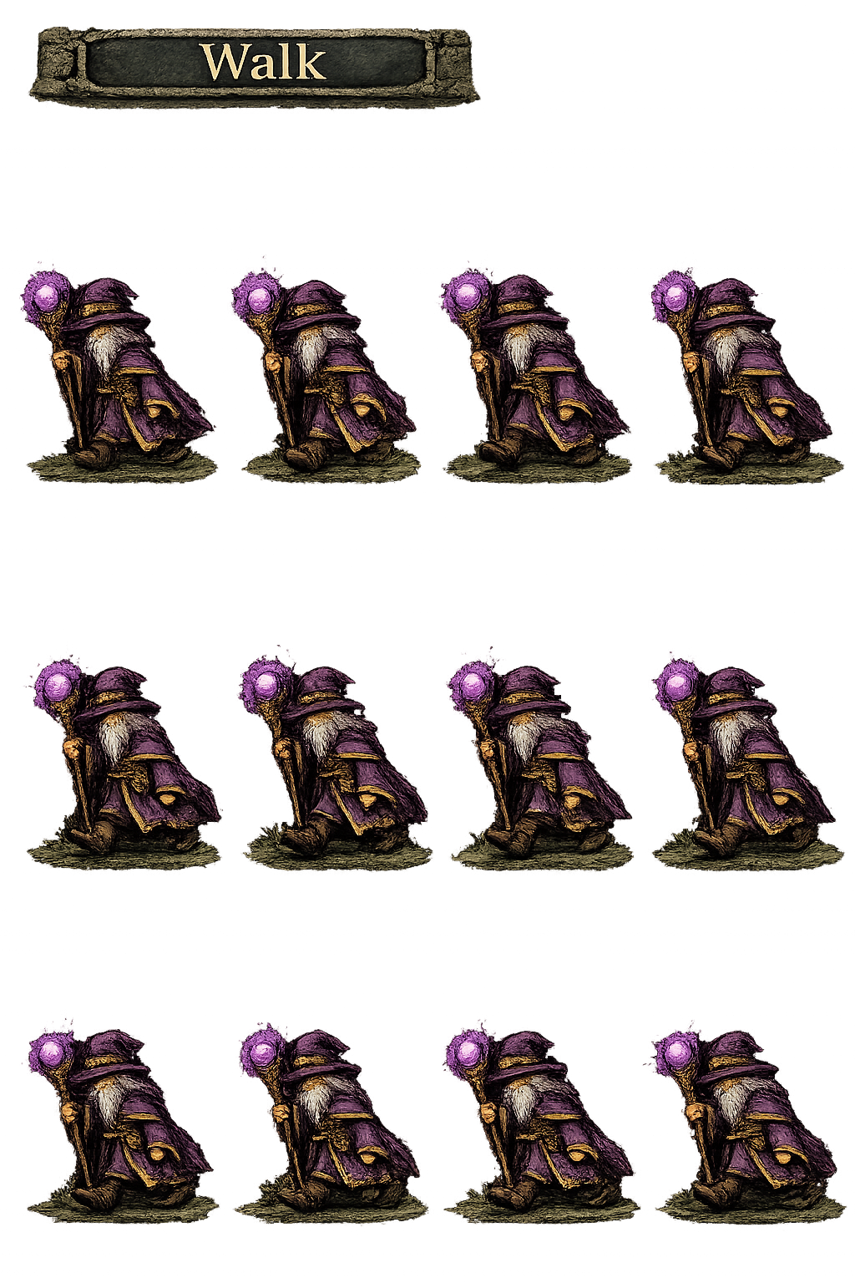

*Current Placeholder AI Generated*

**UI Elements**

We will need to fully replace my placeholder UI (another great opportunity for creativity)

Basically we will need:

* Health Bar
* Timer Element
* Various bars for “food”, “score”, “levelName”, “levelNumber”, “gems”, “timer”, “gold”, etc.
* Various shapes for misc. Menus
* EVENTUALLY all the matching elements for an inventory UI

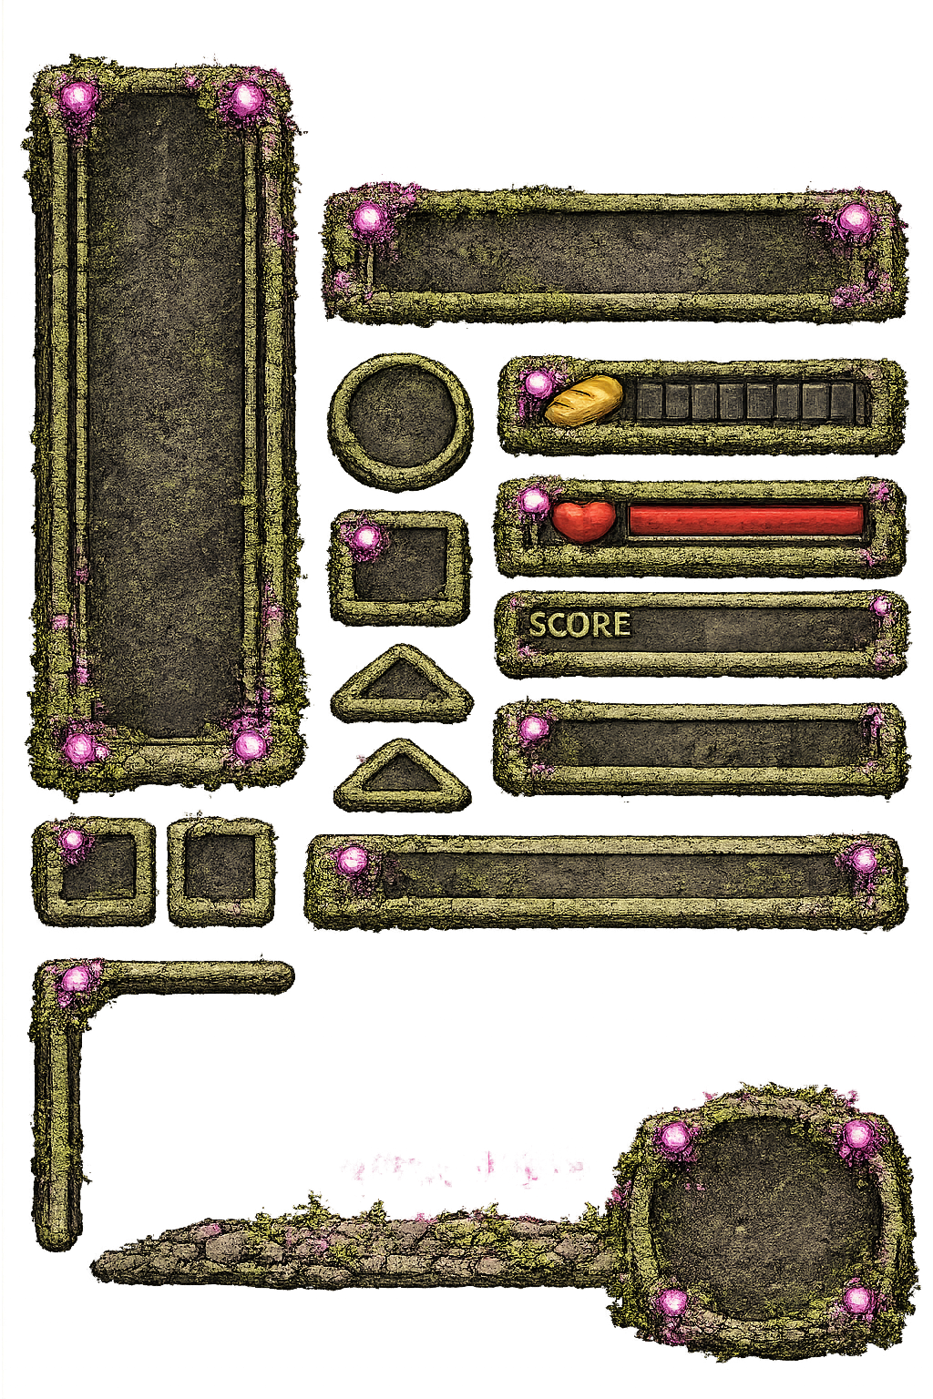

**Collectible / Decor Sprites**

We will also be needing the various collectibles created as well we can get creative here for sure, but in the very least we will need:

* Various Food Sprites
* Various Health Sprites
* Various Gems
* Various Decorative Sprites (Crates, tables, chairs, trees, shrubs, etc)

